HW 3

Ted Henson

1/31/2020

# Question 3

# a)

## [1] 1

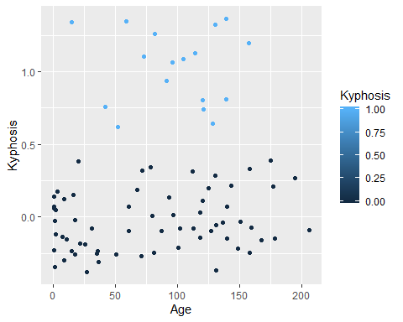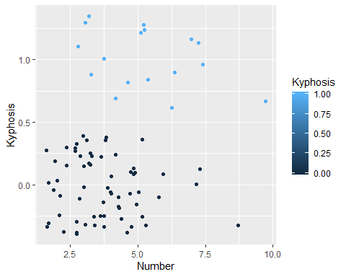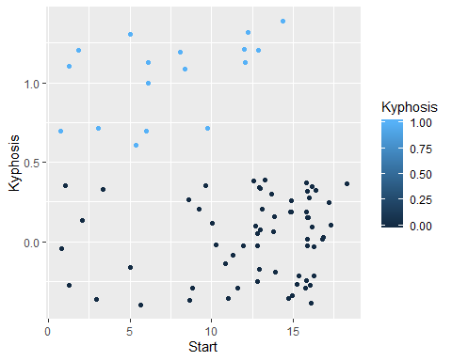

The presence of Kyphosis appears to be rare for higher values of the Start and Number variables.. It seems to be most common for middle values of the Age variable.

# b)

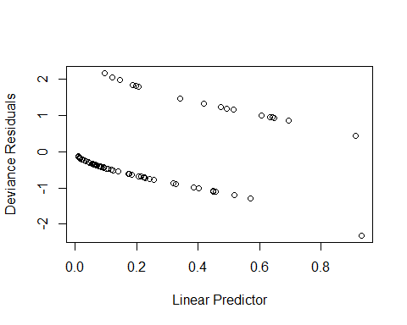 There are only a few cases where Kyphosis is predicted with a probability over 50%. Most of the larger deviance residuals are on the lower end of the predicted response, although there was one outlier in the far upper quantile.

# c)

##   
## Attaching package: 'dplyr'

## The following objects are masked from 'package:stats':  
##   
## filter, lag

## The following objects are masked from 'package:base':  
##   
## intersect, setdiff, setequal, union

## Warning: Factor `cut(linpred, breaks = unique(quantile(linpred)))` contains  
## implicit NA, consider using `forcats::fct_explicit_na`

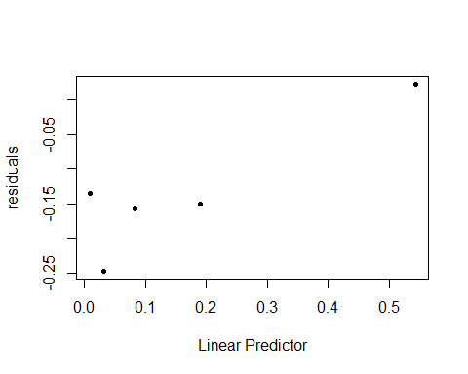

The mean of the residuals seem to be largest for in the lower quantiles of the predicted response values.

#d 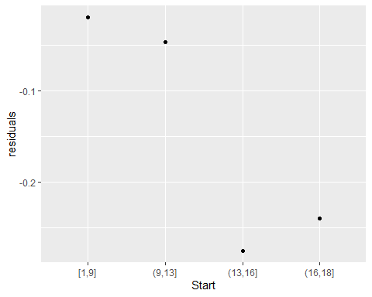

The mean of the residuals are larger at larger values of Start variable.

#e 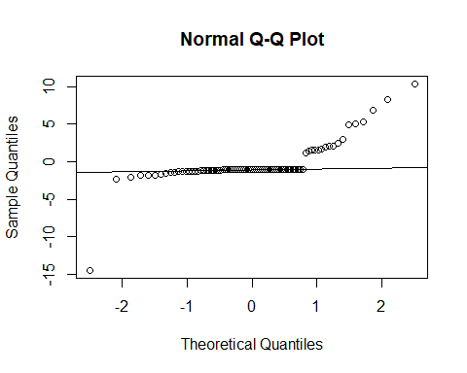

The residuals are much larger in the upper quantiles of the response variable.

# f)

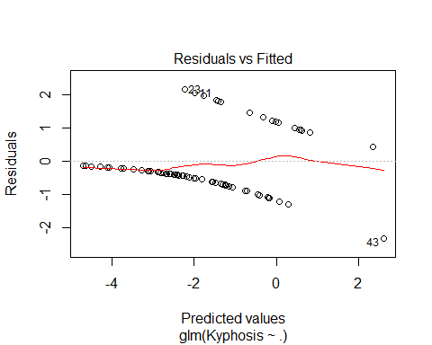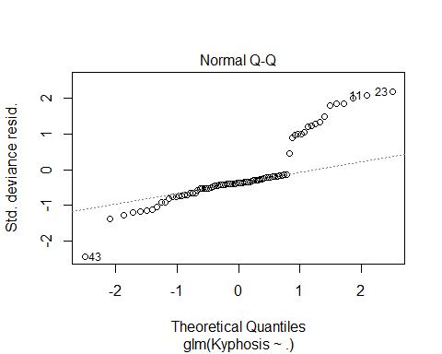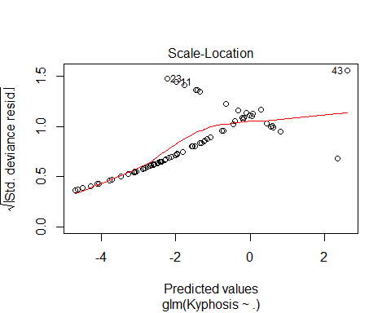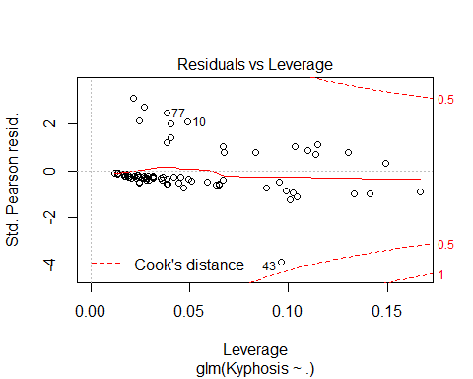

As the fourth plot shows, there are no points that are influential as they are within the dashed cooked lines, although point 43 is very close.

# g)

## Warning: Factor `cut(linpred, breaks = unique(quantile(linpred)))` contains  
## implicit NA, consider using `forcats::fct_explicit_na`

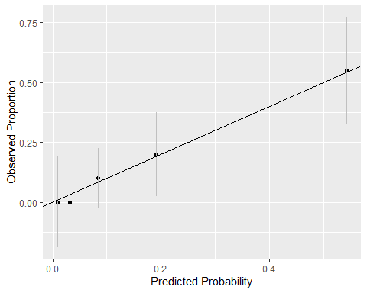

## Loading required package: reshape

##   
## Attaching package: 'reshape'

## The following object is masked from 'package:dplyr':  
##   
## rename

## Loading required package: MASS

##   
## Attaching package: 'MASS'

## The following object is masked from 'package:dplyr':  
##   
## select

##   
## Hosmer and Lemeshow test (binary model)  
##   
## data: kyphosis$Kyphosis, kyphosis$predprob  
## X-squared = 0.056836, df = 0, p-value < 2.2e-16

The p value for the hosmer-lemeshow test was about .05 using 3 quantile groups and basically zero using two quantile groups. Therefore, the model predicting the two groups has statistical significance of a good fit.

# h)

## predout  
## Kyphosis no yes  
## 0 61 3  
## 1 10 7

When Kyphosis is present, the model would predict it is present with probability 0.4117647. This would be the true positive rate.

# Question 4

# a)

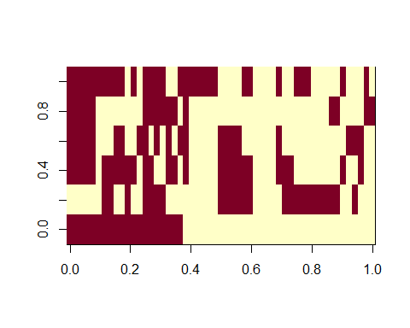

# b)

##   
## Call:  
## glm(formula = r ~ ., family = "binomial", data = nodal)  
##   
## Deviance Residuals:   
## Min 1Q Median 3Q Max   
## -2.3317 -0.6653 -0.2999 0.6386 2.1502   
##   
## Coefficients:  
## Estimate Std. Error z value Pr(>|z|)   
## (Intercept) -3.0794 0.9868 -3.121 0.0018 **  
## aged -0.2917 0.7540 -0.387 0.6988   
## stage 1.3729 0.7838 1.752 0.0799 .   
## grade 0.8720 0.8156 1.069 0.2850   
## xray 1.8008 0.8104 2.222 0.0263 *   
## acid 1.6839 0.7915 2.128 0.0334 *   
## ---  
## Signif. codes: 0 '***' 0.001 '**' 0.01 '*' 0.05 '.' 0.1 ' ' 1  
##   
## (Dispersion parameter for binomial family taken to be 1)  
##   
## Null deviance: 70.252 on 52 degrees of freedom  
## Residual deviance: 47.611 on 47 degrees of freedom  
## AIC: 59.611  
##   
## Number of Fisher Scoring iterations: 5

## Waiting for profiling to be done...

## 2.5 % 97.5 %  
## (Intercept) -5.3002078 -1.362046  
## aged -1.7956919 1.214897  
## stage -0.1313106 3.000236  
## grade -0.7346704 2.539458  
## xray 0.2669083 3.523458  
## acid 0.2089821 3.378604

Yes the Xray and Acid variables both have p values below the .05 threshold and strictly positive 95% confidence intervals.

# c)

##   
## Call:  
## glm(formula = r ~ stage + xray + acid, data = nodal)  
##   
## Deviance Residuals:   
## Min 1Q Median 3Q Max   
## -0.8766 -0.2554 0.0238 0.1234 1.0238   
##   
## Coefficients:  
## Estimate Std. Error t value Pr(>|t|)   
## (Intercept) -0.0238 0.1000 -0.238 0.81298   
## stage 0.2792 0.1137 2.455 0.01768 *   
## xray 0.3510 0.1244 2.822 0.00688 **  
## acid 0.2702 0.1149 2.352 0.02274 *   
## ---  
## Signif. codes: 0 '***' 0.001 '**' 0.01 '*' 0.05 '.' 0.1 ' ' 1  
##   
## (Dispersion parameter for gaussian family taken to be 0.165372)  
##   
## Null deviance: 12.4528 on 52 degrees of freedom  
## Residual deviance: 8.1032 on 49 degrees of freedom  
## AIC: 60.872  
##   
## Number of Fisher Scoring iterations: 2

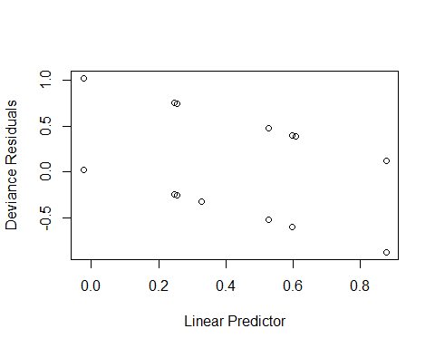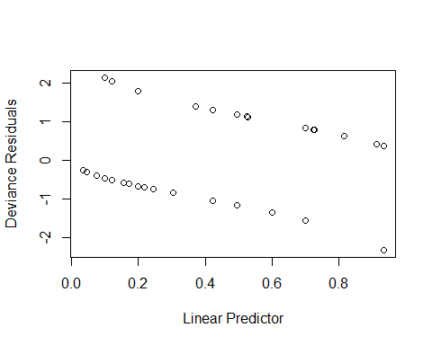

Yes the smaller model could be preferred over the larger model because the deviance residuals are much smaller.

# d)

A serious x ray result increases the odds of having nodal involvement by 1.4205216 compared to a non serious x ray result. The 95% confidence interval for the change in odds is 1.0579312, 1.6522249

# e)

## Warning: glm.fit: fitted probabilities numerically 0 or 1 occurred

##   
## Call:  
## glm(formula = r ~ .^2, family = binomial, data = nodal)  
##   
## Deviance Residuals:   
## Min 1Q Median 3Q Max   
## -1.89302 -0.00016 0.00000 0.00015 1.89302   
##   
## Coefficients:  
## Estimate Std. Error z value Pr(>|z|)  
## (Intercept) -38.55 31256.82 -0.001 0.999  
## aged -54.81 32392.28 -0.002 0.999  
## stage 74.21 11937.81 0.006 0.995  
## grade 38.55 31256.82 0.001 0.999  
## xray 17.18 16447.57 0.001 0.999  
## acid 36.94 31256.82 0.001 0.999  
## aged:stage 18.46 7928.05 0.002 0.998  
## aged:grade 31.97 38433.52 0.001 0.999  
## aged:xray 56.96 17366.75 0.003 0.997  
## aged:acid 36.35 31407.10 0.001 0.999  
## stage:grade -92.34 14996.24 -0.006 0.995  
## stage:xray -17.06 28388.60 -0.001 1.000  
## stage:acid -72.60 11937.81 -0.006 0.995  
## grade:xray 36.50 31778.73 0.001 0.999  
## grade:acid 54.48 31841.24 0.002 0.999  
## xray:acid -35.70 8157.65 -0.004 0.997  
##   
## (Dispersion parameter for binomial family taken to be 1)  
##   
## Null deviance: 70.252 on 52 degrees of freedom  
## Residual deviance: 29.542 on 37 degrees of freedom  
## AIC: 61.542  
##   
## Number of Fisher Scoring iterations: 20

The standard errors are very large because there is not enough data (information) to estimate all of the parameters. Some of the two way interactions are probably collinear with the original variables as well.

# f)

## Loading required package: profileModel

## 'brglm' will gradually be superseded by 'brglm2' (https://cran.r-project.org/package=brglm2), which provides utilities for mean and median bias reduction for all GLMs and methods for the detection of infinite estimates in binomial-response models.

##   
## Call:  
## brglm(formula = r ~ .^2, family = binomial, data = nodal)  
##   
##   
## Coefficients:  
## Estimate Std. Error z value Pr(>|z|)  
## (Intercept) -2.6438 1.6586 -1.594 0.111  
## aged -0.6995 1.8290 -0.382 0.702  
## stage 2.3156 1.8196 1.273 0.203  
## grade 2.6023 1.9506 1.334 0.182  
## xray 0.6900 2.0954 0.329 0.742  
## acid 1.2729 1.8124 0.702 0.483  
## aged:stage 0.3728 1.8119 0.206 0.837  
## aged:grade -1.5480 1.8594 -0.833 0.405  
## aged:xray 1.4587 1.9780 0.737 0.461  
## aged:acid 0.3634 1.7722 0.205 0.838  
## stage:grade -2.8219 1.8258 -1.546 0.122  
## stage:xray 0.8375 2.2944 0.365 0.715  
## stage:acid -0.9608 1.6387 -0.586 0.558  
## grade:xray -0.1890 2.2626 -0.084 0.933  
## grade:acid 0.5575 1.8918 0.295 0.768  
## xray:acid -0.2560 1.8611 -0.138 0.891  
##   
## (Dispersion parameter for binomial family taken to be 1)  
##   
## Null deviance: 45.450 on 52 degrees of freedom  
## Residual deviance: 38.997 on 37 degrees of freedom  
## Penalized deviance: 45.20152   
## AIC: 70.997

The stage and grade interaction has the largest coefficient.

# g)

## predout  
## r 0 1  
## 0 29 4  
## 1 4 16

## predout  
## r 0 1  
## 0 30 3  
## 1 7 13

The bias reduced model had one less miss classification than the full model. These models are probably over estimates of the classification rates of what one could expect in the future. Cross validation or boot strapping would need to be implemented to get a better idea of the future classification accuracy.